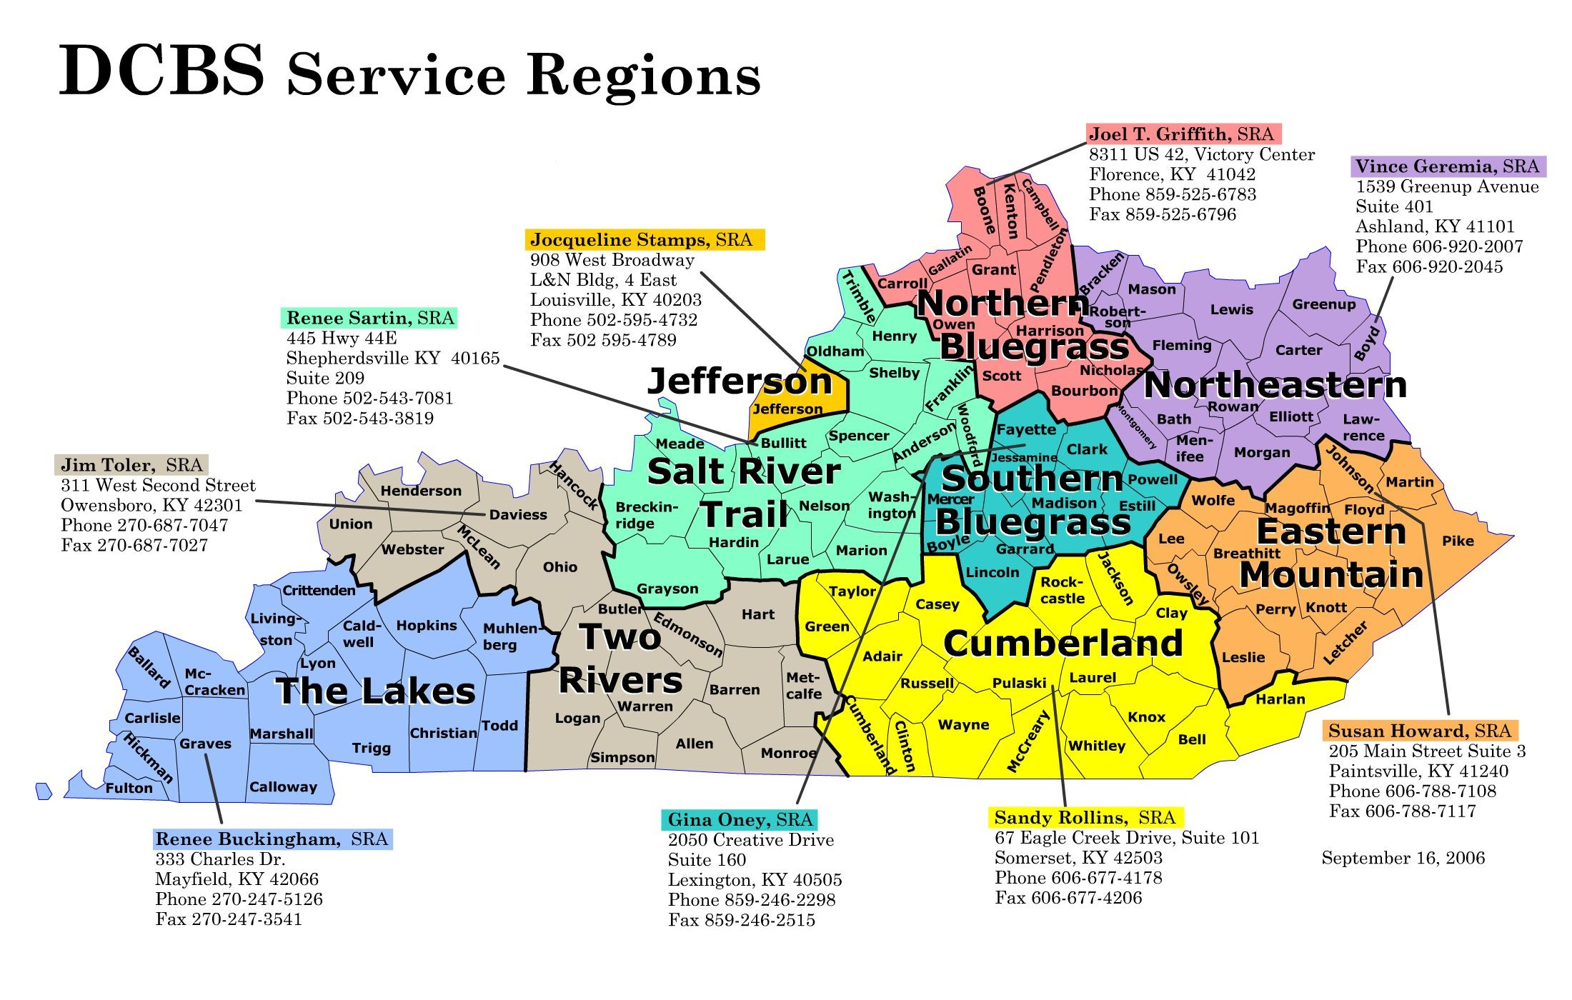

A – J

Breckinridge, Grayson, Hardin, Larue, Marion, Meade, Nelson Washington

**Phone:** 270-422-3974

K – Z

Breckinridge, Grayson, Hardin, Larue, Marion, Meade, Nelson Washington

**Phone:** 270-358-4175

Bullitt, Henry, Oldham, Shelby, Spencer, Trimble **Phone:** 502-633-1892

A-B-G

**Phone:** 502-595-5252

C-D-E-F-X-Y-Z

**Phone:** 502-595-5251H-I-J-K-L

**Phone:** 502-595-5250M-N-O-P-Q-R

**Phone:** 502-595-5305

S-T-U- V-W

**Phone:** 502-595-3110 **Phone:** 502-595-5249

**DCBS/DAFM  
OOHC Children’s Benefits Worker Phone Listing  
4/01/14  
Central Office–502/564-3427  
Daviess County–270-687-7047 ext 2213**

Hart, Monroe, Allen, Barren, Butler, Edmonson, Logan, Metcalfe, Simpson **Phone:** 270-746-7447Daviess, Hancock

**Phone:** 270-687-7047

Henderson, Ohio, Union, McClean Webster **Phone:** 270-687-7047

Warren **Phone:** 270-746-7447

Floyd, Johnson, Magoffin, Martin, Pike

**Phone:** 606-788-7108Breathitt, Knott, Lee, Leslie, Letcher, Owsley, Perry, Wolfe **Phone:** 606-435-6052

Anderson, Garrard, Jessamine, Franklin, Mercer, Woodford **Phone:** 859-623-1204

Fayette (A – J) **Phone:** 859-271-3765 x 763Fayette (K – Z) **Phone:** 859-271-3765 x 694

Bourbon, Boyle, Clark, Lincoln, Harrison, Nicholas, Estill **Phone:** 859-623-1204Madison, Powell, Scott

**Phone:** 859-623-9119

Caldwell, Christian, Crittenden, Hopkins, Livingston, Lyon, Muhlenberg, Todd, Trigg

**Phone:** 270-889-6573

Ballard, Calloway, Carlisle, Graves, Hickman, Marshall **Phone:** 270-575-7153

Fulton, McCracken **Phone:** 270-575-7054

Boyd, Carter, Elliott, Greenup, Lawrence

**Phone:** 606-638-4360

Bath, Bracken, Fleming, Lewis, Mason, Menifee, Montgomery, Morgan, Robertson, Rowan

**Phone:** 606-784-6687

Bell, Harlan, Knox, Whitley

**Phone:** 606-677-4103

Clay, Jackson, Laurel, Rockcastle **Phone:** 606-330-2001

Adair, Casey, Clinton, Cumberland, Green, McCreary, Pulaski, Russell, Taylor, Wayne **Phone:** 606-387-6446

A - G

**Phone:** 859-292-6340

H - N

**Phone:** 859-292-6340

O – Z

**Phone:** 859-292-6340